About Hacking Club
Hacking Club is a platform to learn cybersecurity, an incredible resource if you don’t know where to start. In addition to vulnerable machines, you have access to classes and challenges to practice your skills and access to an exclusive community to play and challenge yourself.

The best part about Hacking Club is that it is very hands-on. If you are new to hacking, give it a try.

Introduction
This write-up refers to the MALDEV machine. If you require support, please open a ticket in the support channel on the Discord server.

Nmap Scan:
We need to know which services are running in the background and which ports are open. So, we will use a tool called nmap.
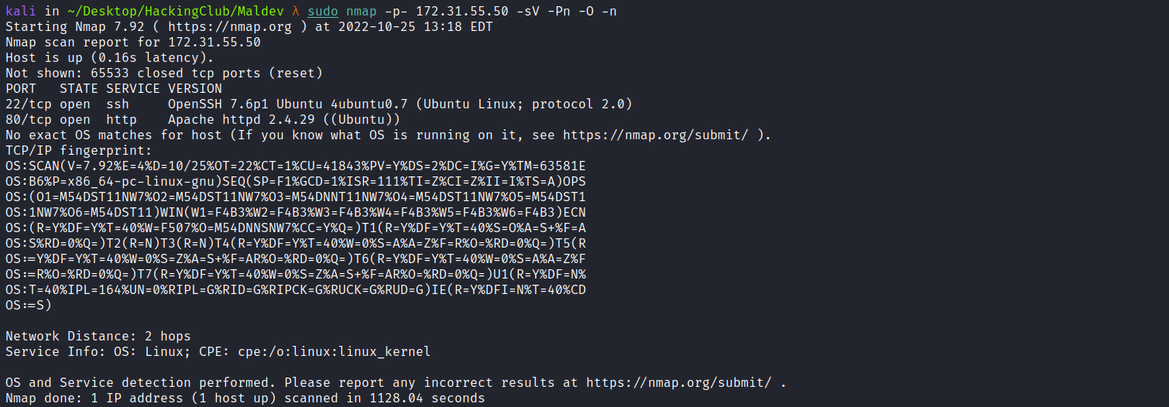
- Port 22 - SSH
- Port 80 - HTTP
We can start by looking at the website running on port 80:

We can try using some default credentials such as admin:admin, guest:guest, etc., but without success.
We can perform fuzzing on this application to find possible relevant files or directories. For this, I will use the tool ffuf.
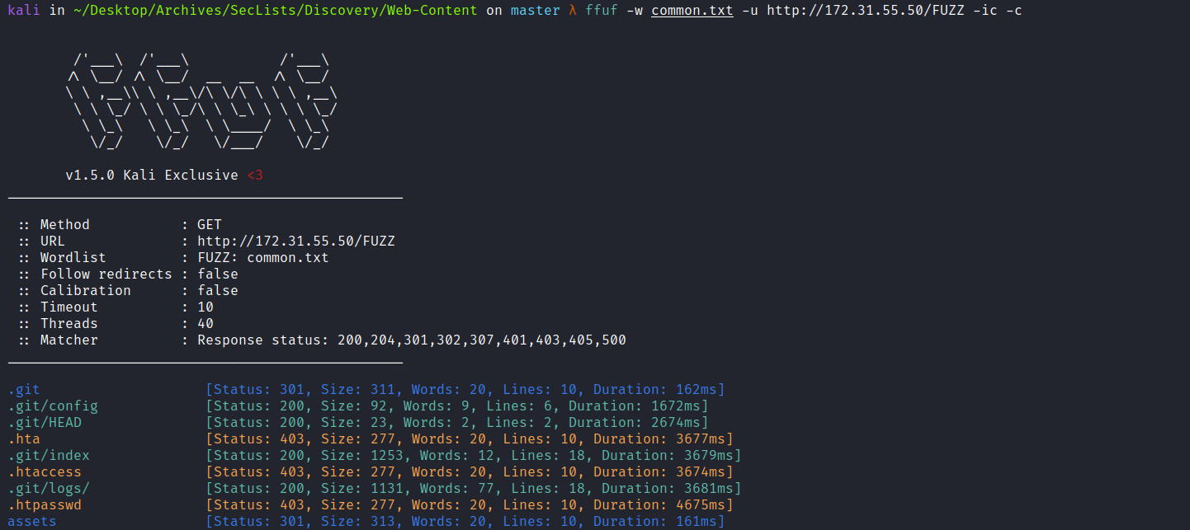
After performing fuzzing, we find an exposed Git repository. We can use the tool git-dumper to dump it:
https://github.com/arthaud/git-dumper

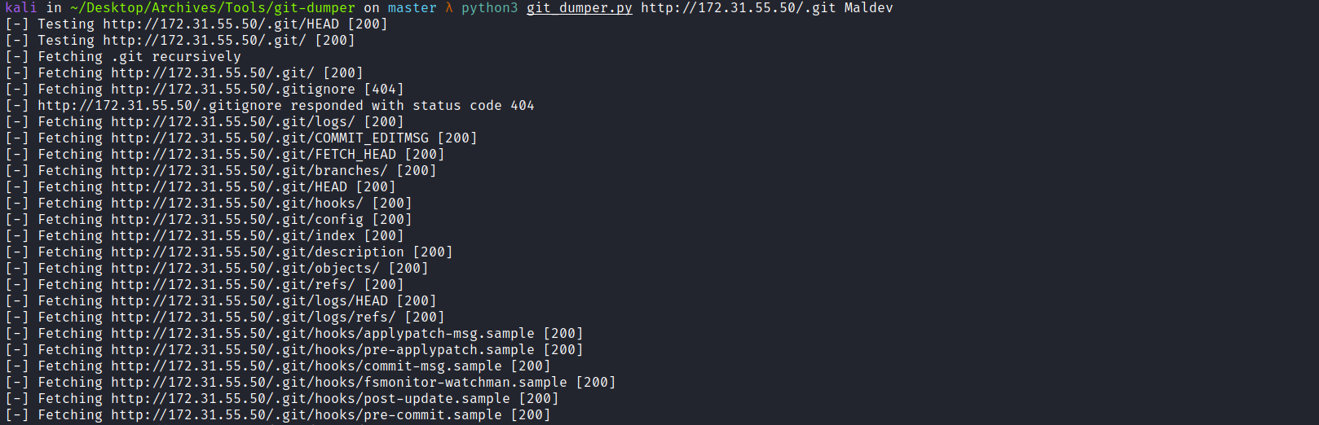
After dumping it, we can open the files in Visual Studio Code for better visualization.
Performing a code review on the file login.php, we can notice that it is vulnerable to type juggling.
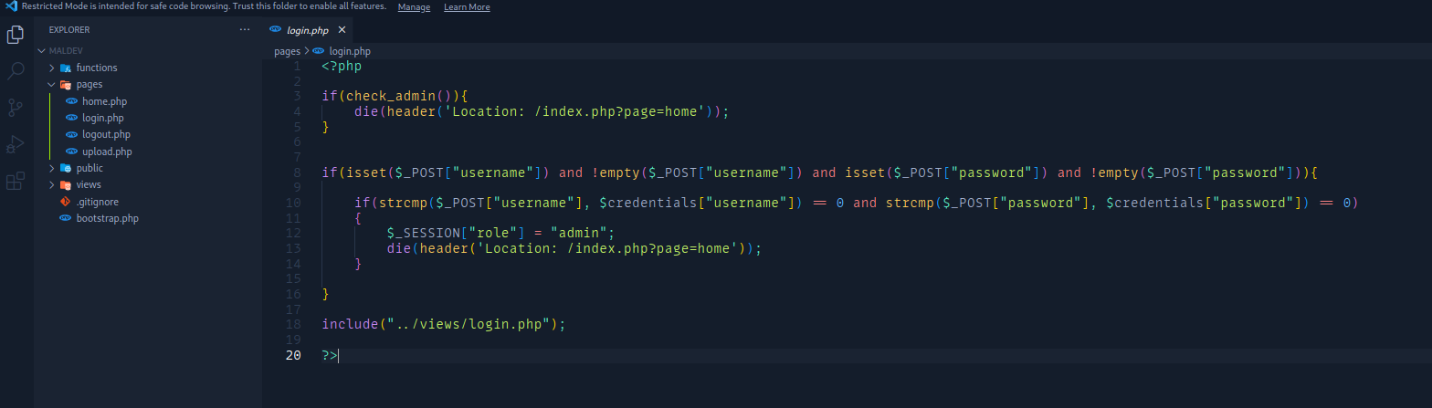
Knowing this, we have an authentication bypass. Since the verification expects the comparison result to return 0, we can transform the variables into an array. During comparison, it will trigger a Warning and return the value 0, allowing us to bypass authentication.
We can intercept the request using Burp Suite.
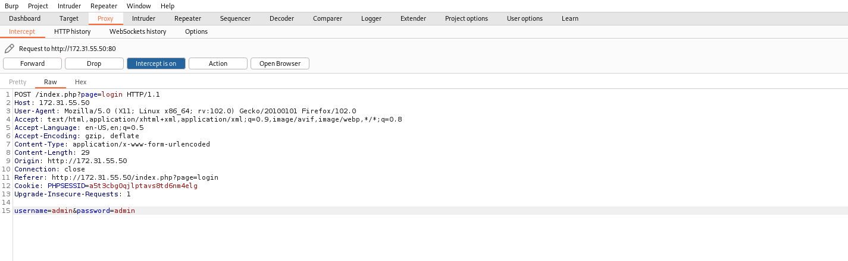We then transform the types of the variables username and password into arrays [].
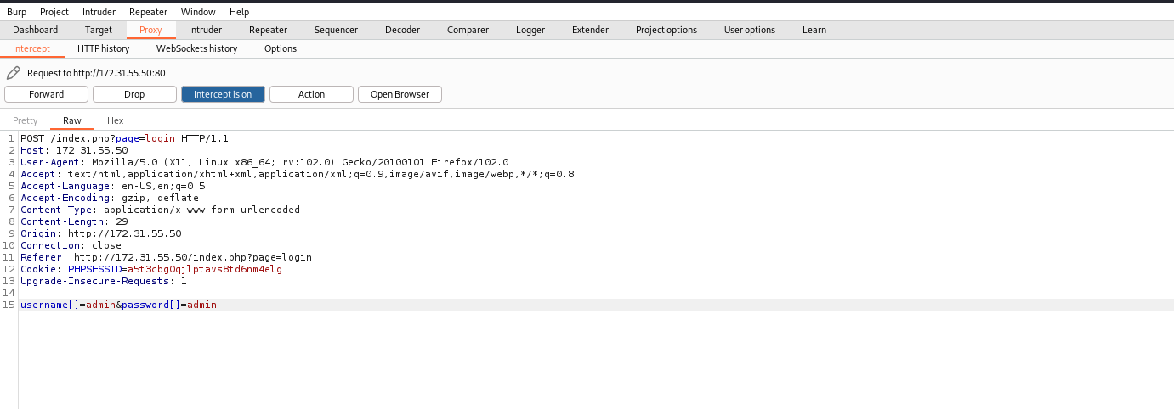
After doing this, we gain access to the application’s home page.
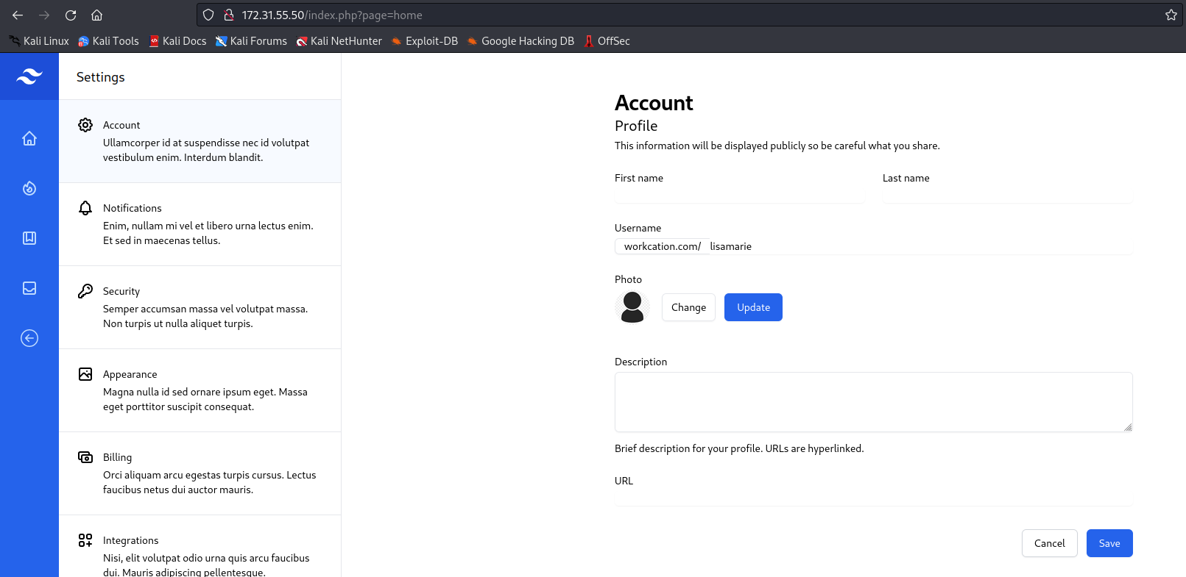
After gaining access to the home page, we can continue with the code review.
Analyzing the file index.php, we notice that we have an insecure deserialization vulnerability.
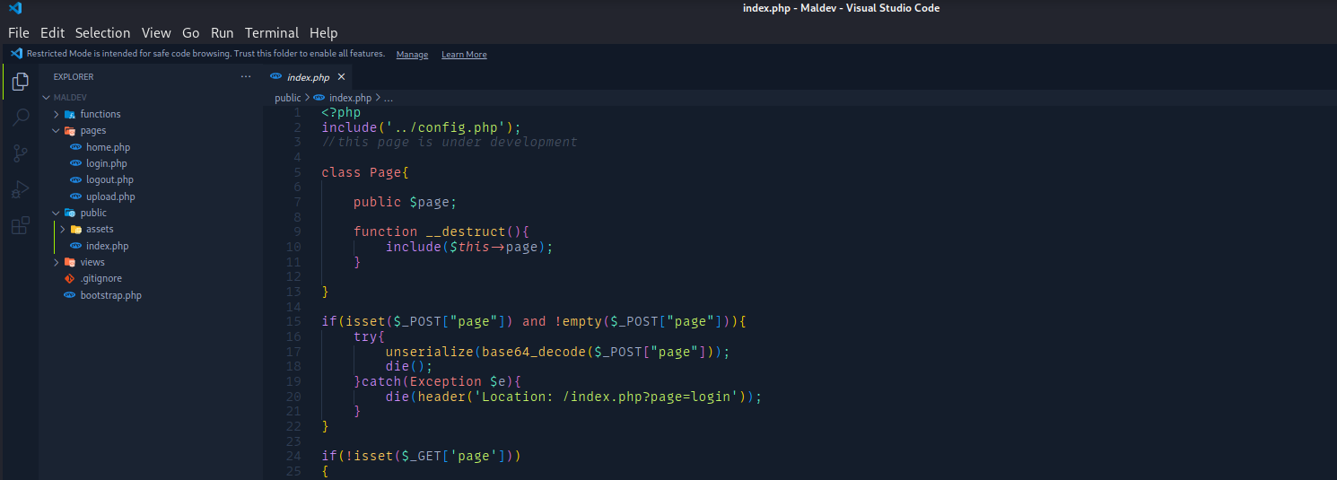
Since we control the $page property and it will be included using the include() function, we can obtain RCE. However, to do this, we must send a file containing our reverse shell.
We can take a look at the file upload.php.
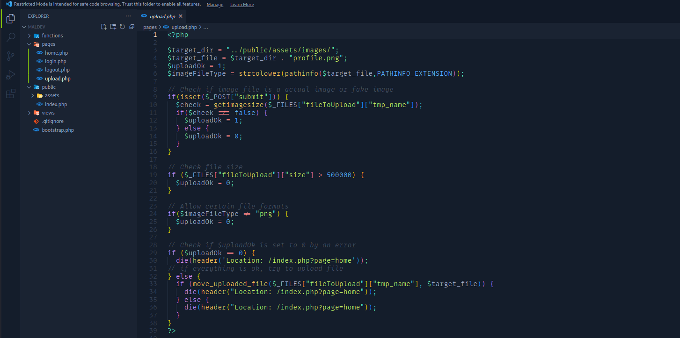
After analyzing upload.php, we notice that we must send our payload in a file with the .png extension. Another interesting detail is that target_file will always keep the name profile.png. Knowing this, we can create our exploit.
We can start by creating our reverse shell:
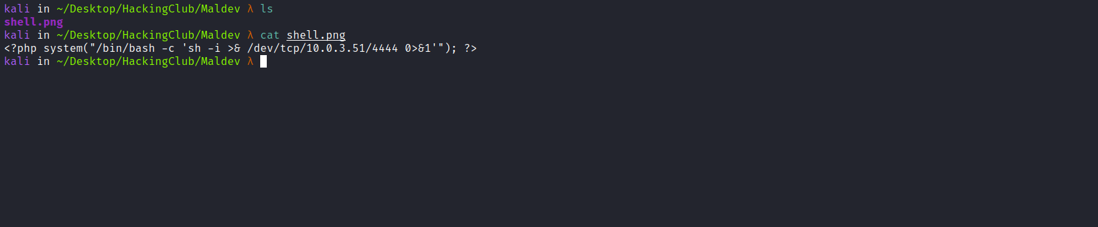
Now we upload it.
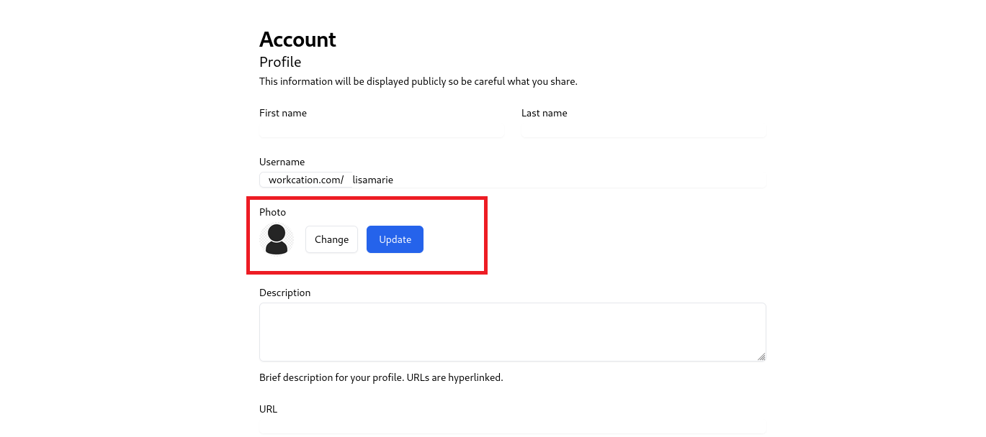
We can write our exploit. Since we know the path of profile.png and that it will keep the same name, our exploit will look like this:
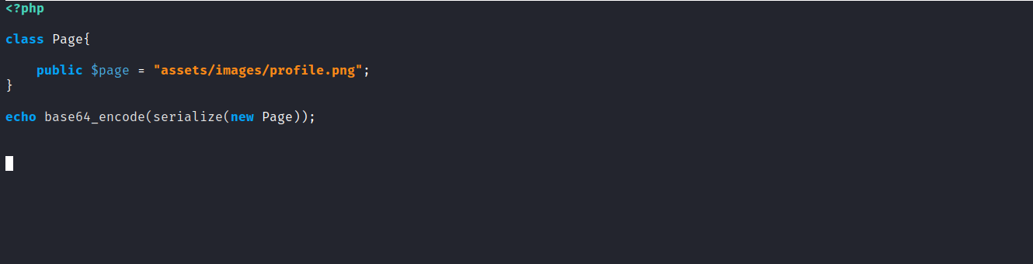
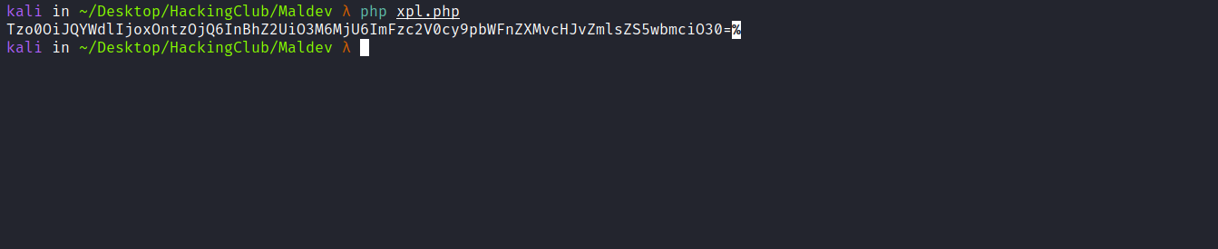
Netcat listener to receive the connection:
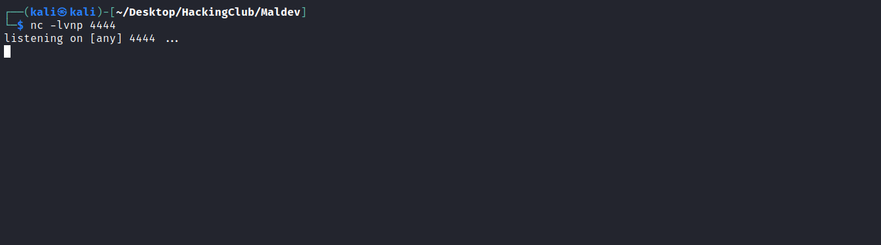
We can send our payload by making a POST request to index.php and passing it in the parameter page=.
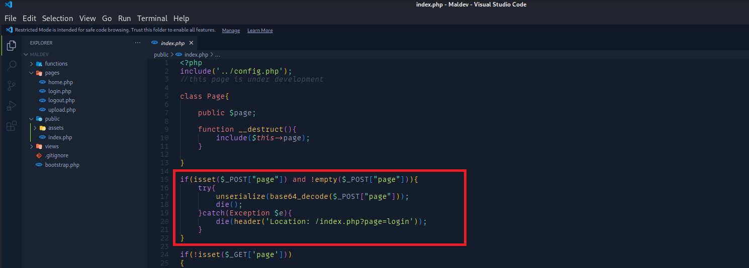
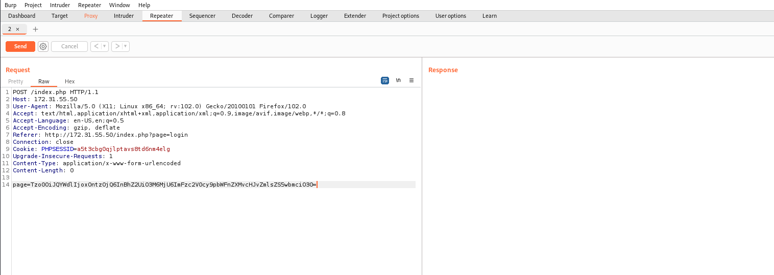
After sending the request, we receive the shell.
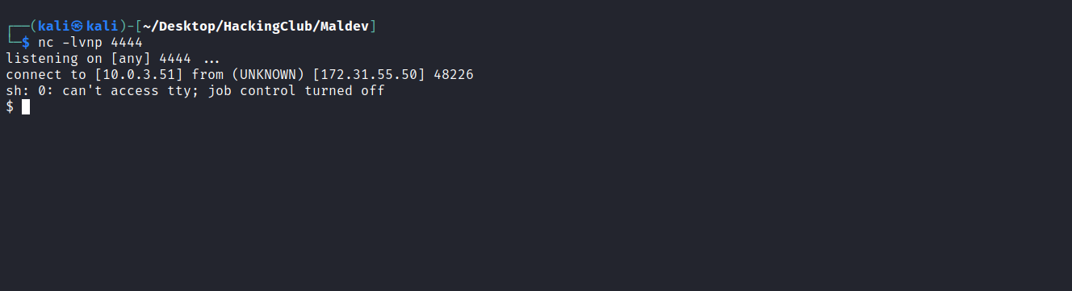

Shell tty
Upgrading a simple shell to fully interactive TTYs:
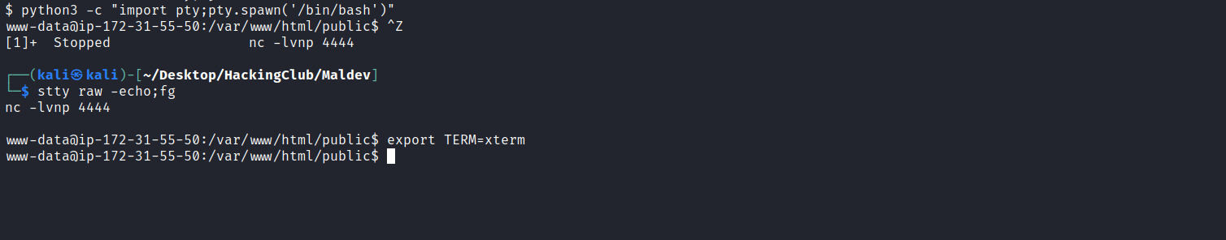
Listing the / directory, we can find our first flag.
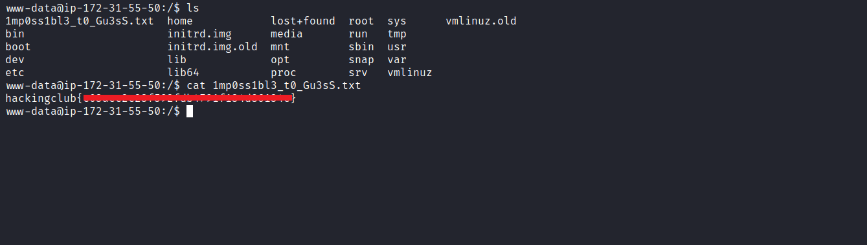

Privesc
When analyzing the file /etc/crontab, we notice that we have a task being executed every 1 minute.
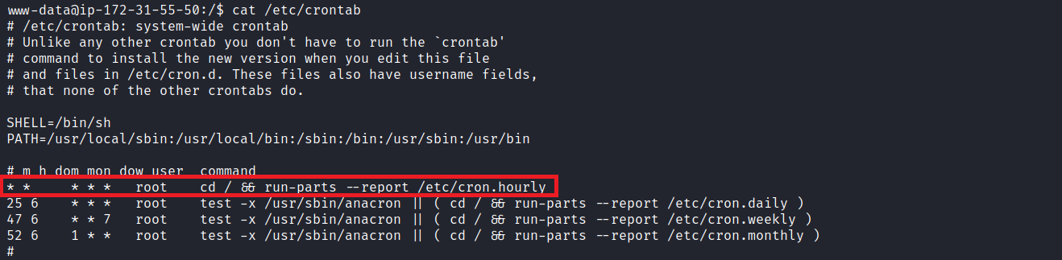
Knowing this, we can try to overwrite the run-parts binary by adding a reverse shell to it. However, for this, we need to check its permissions.
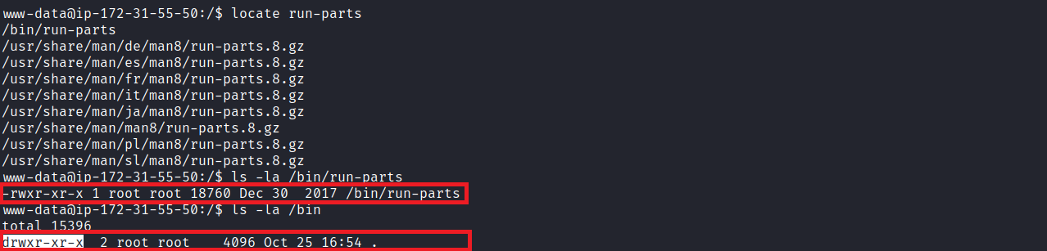
We do not have write permissions on the file nor on the directory where it is located.
We can analyze the crontab path:
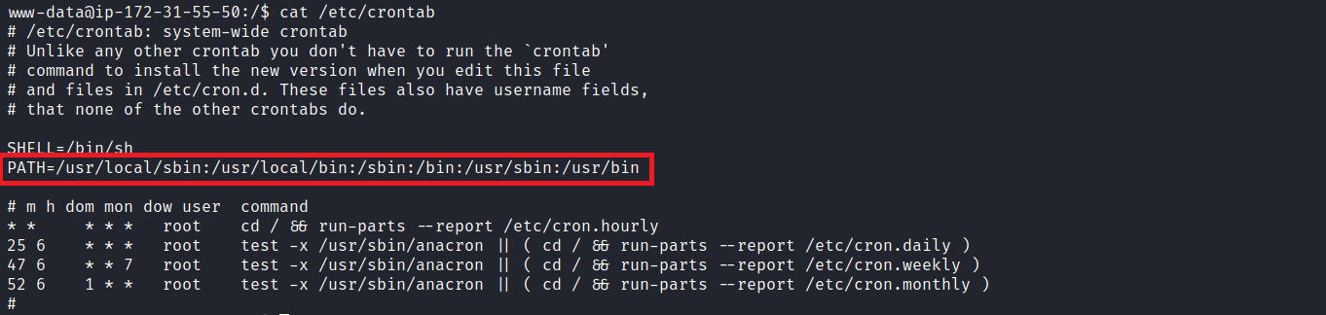
We know that the first path it will search for the run-parts binary is /usr/local/sbin.
We can check the permissions of this directory.
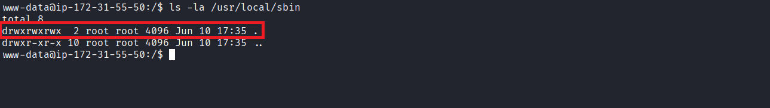
We have write permissions on it. Since we know that crontab will search for the binary in the first path defined in the PATH variable, we can create our fake run-parts containing our reverse shell:
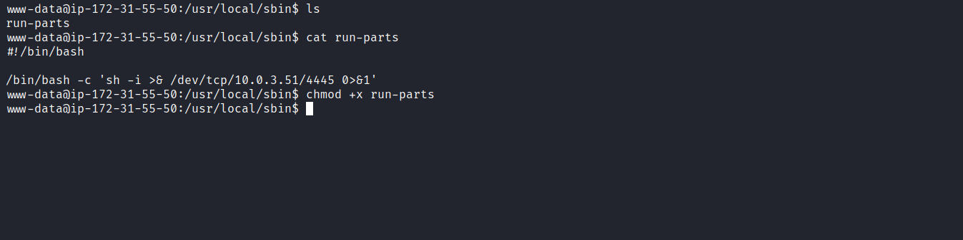
Netcat listener to receive the connection:
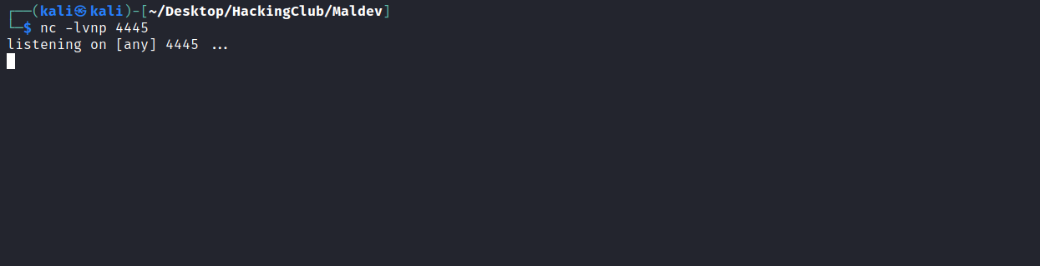
After 1 minute, we receive the connection.
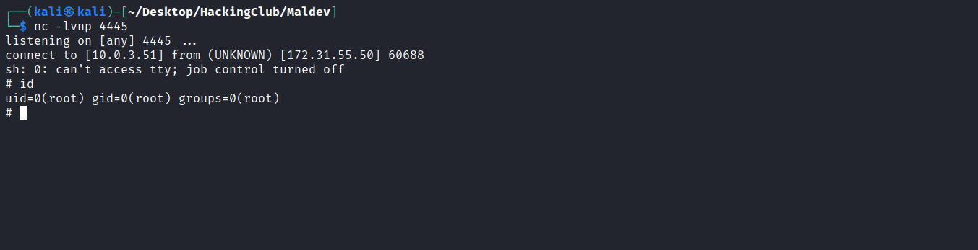
And with that, we can retrieve our final flag:
